Question 1 Nazi Germany
  - Explain the following:
    - Democracy
    - Dictator
    - Cold War
    - Capitalism
    - Propaganda
    - Swastika
    - Holocaust
    - Communism
    - Fascism
    - Allied powers
(20)
1.2. What treaty is being referred to in Source A? (1x2)
1.3 According to Source A, how did Hitler feel about this treaty? (2x2)
1.4 How would Hitler get vengeance (revenge) for this treaty? (1x2)
1.5 Sources B, C and D show various aspects of Hitler's reign. How do they show that Nazi Germany was a fascist country? (2x2)
1.6 How does the poster (source B) try to persuade Germans to support Hitler? (2x2)
1.7 Why do you think the Nazis organised large rallies such as the one depicted in Source D? (2x2)
1.8 Write a paragraph of 10 lines describing life in Nazi Germany. (15)
[35]
Question 2 The war in the Pacific
2.1. Refer to Source E. Explain the mixed feelings that this Japanese suicide pilot had before his final flight. (2x2)
2.2. Which words from Source E show that he had no control over his life as a pilot? (1x2)
2.3. Is Source E a primary or secondary source? Give reasons for your answer. (2x2)
2.4. Why did McLemore hate the Japanese so much? (2x2)
2.5 Write a paragraph of 10 lines explaining why America dropped atom bombs on Japan. (15)
[29]

Question 3 The Cold War
3.1. Refer to Source G.
3.1.1 Why did Churchill co-operate with Stalin? (1x2)
3.1.2 What evidence is therein the source that Churchill did not trust Stalin? (1x2)
3.2 Read Sources H.
3.2.1 Why did Truman become president of the USA? (1x2)
3.2.2 What did Truman suggest is the best way to deal with the Russians? (1x2)
3.2.3 How would Truman’s attitude towards the Russians (Soviets) increase tension between the USA and USSR? (2x2)
3.3 Refer to source I.
3.3.1 What two (2) criticisms did the Soviets have of America? (2x2)
[16]
Total: 100

Addendum
Source A
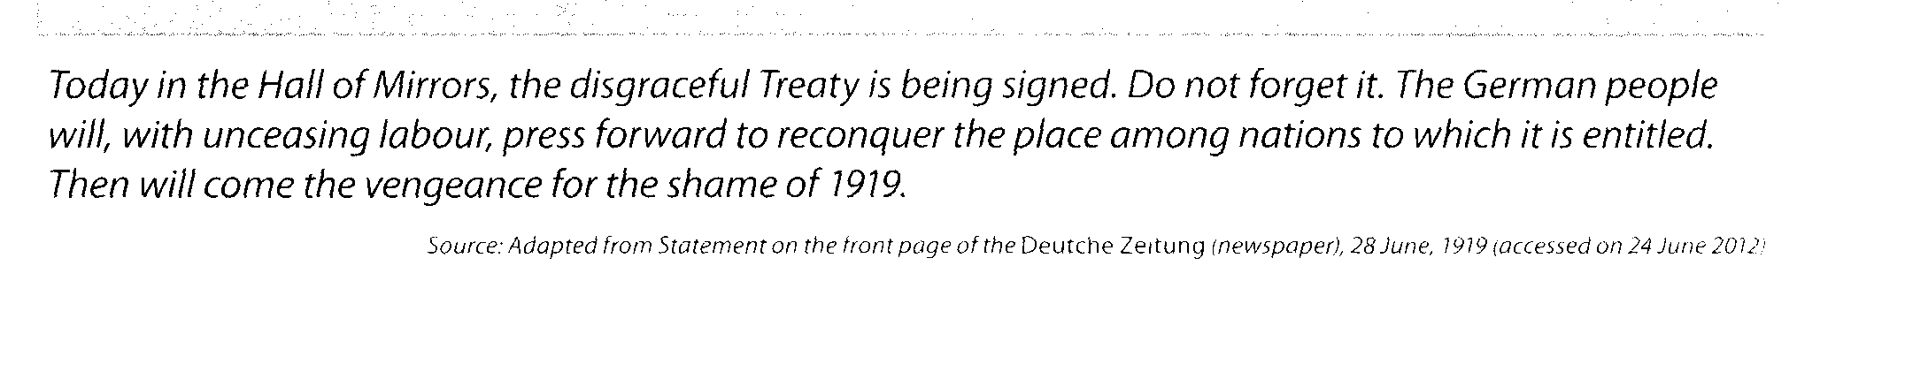

Source B
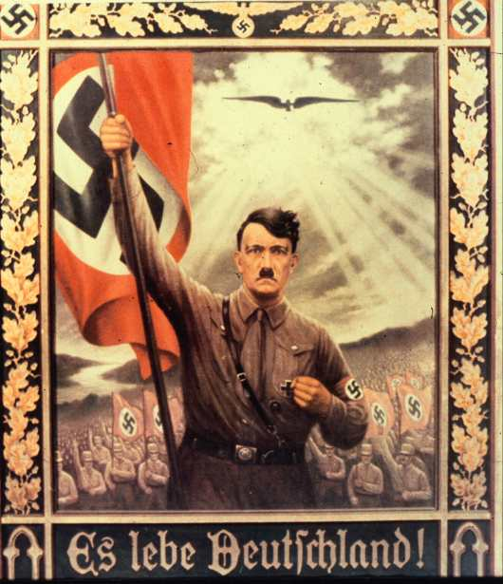

Source C Jews being forced by Nazis to carry Anti-Semitic Signs
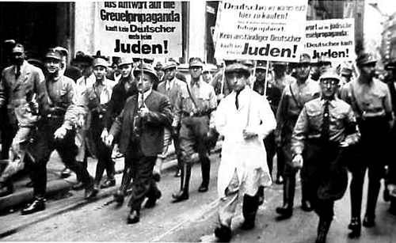

Source D A Nazi rally.
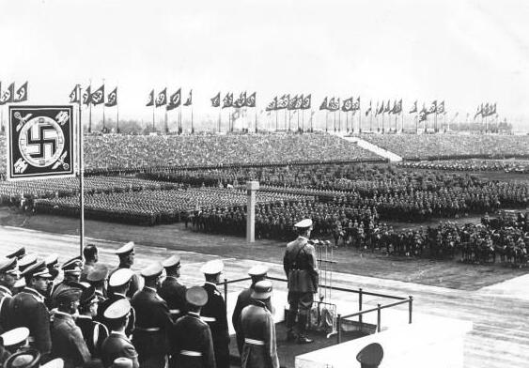

Source E
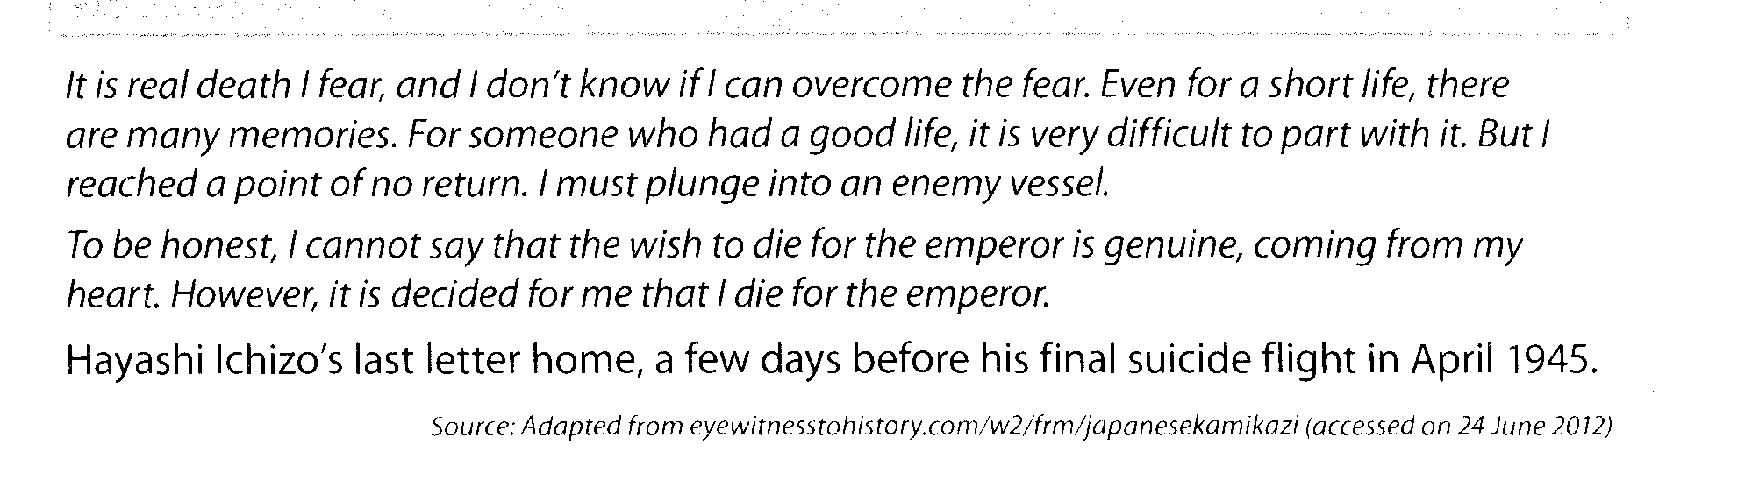
Source F
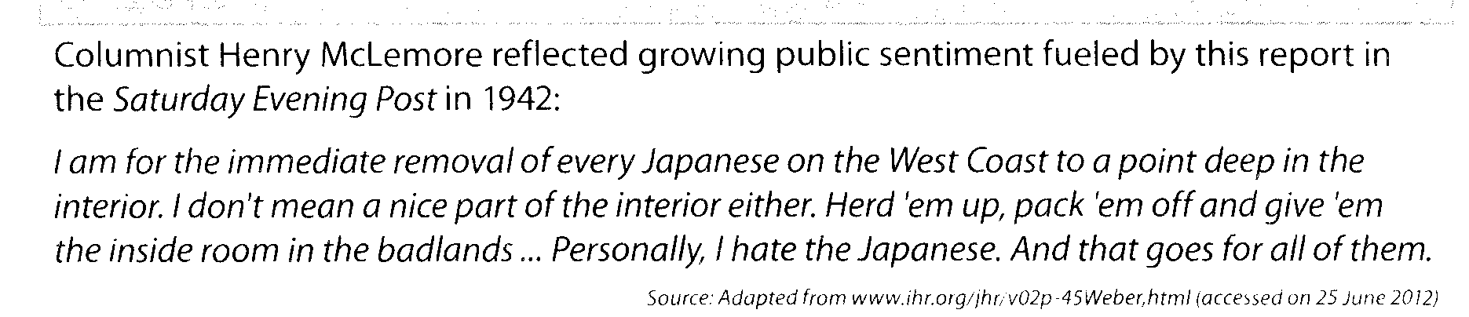

Source G
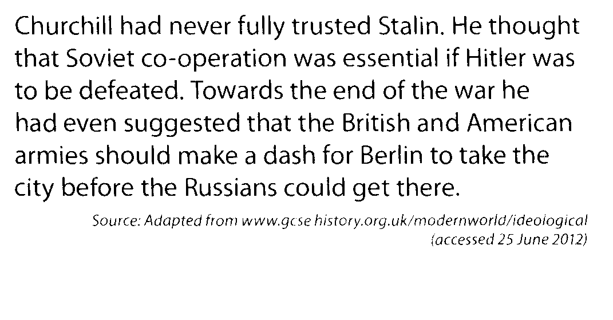

Source H
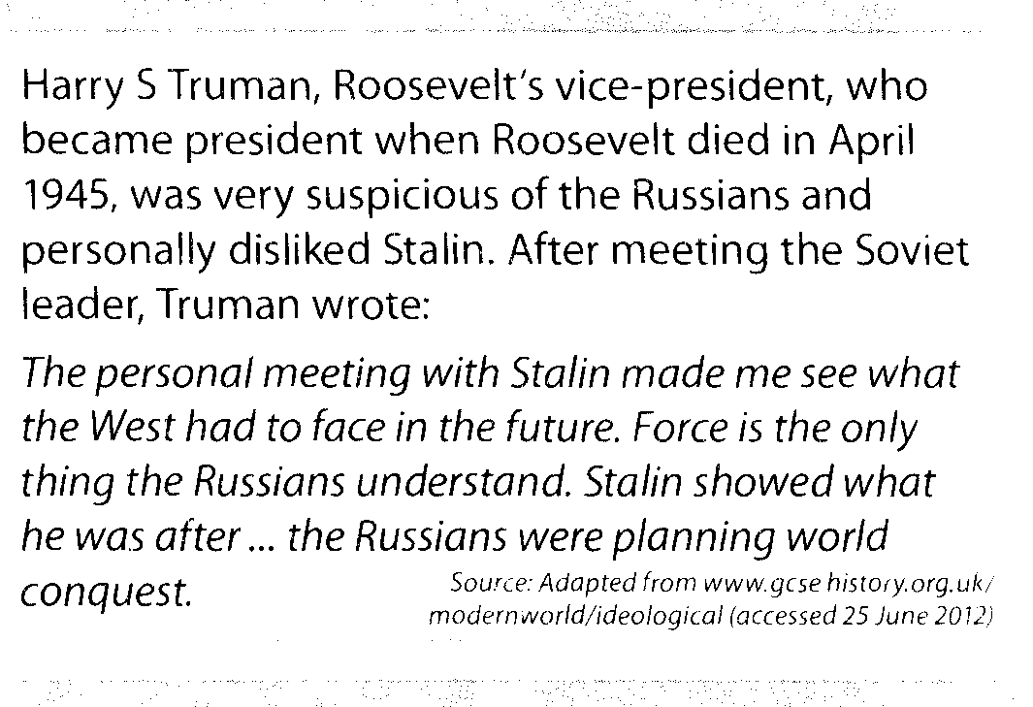

Source I
